7. Valuation
Three methods triangulate Organon’s standalone value. Base-case DCF: enterprise value ~$12.4bn, equity ~$16.5/share. Trading comps (6.0–7.5x EV/EBITDA): ~$11.5–14.3bn. Precedent transactions (7.0–9.0x): ~$13.4–17.2bn. The $14.00 offer sits at the low end of DCF and comps and well below precedents. Read: the price is fair-to-cheap for Sun and defensible-but-not-generous for Organon holders, consistent with a levered asset in secular decline.

7.1 DCF — assumptions
Standalone, unlevered, five-year explicit forecast (2026–2030) plus terminal value. Analyst assumptions, flagged; anchored on FY2025 actuals.
- Revenue. −2%, −1%, 0%, +1%, +1% — established-brands decline moderating as Women’s Health and Biosimilars mix up. Net ~flat, in line with the five-year history.
- EBITDA margin. 30% (vs 30.7% FY25) — slight erosion for pricing pressure.
- D&A $300m; capex $160m (~2.5% of revenue, mature base); ΔNWC $40m outflow; tax 19% (Organon’s low effective rate).
- Terminal value. Exit 6.0x EV/EBITDA base (a declining-brands multiple), cross-checked vs Gordon growth. Exit multiple preferred over perpetuity growth for an ex-growth asset.

7.2 WACC build
Component | Value
Risk-free rate (US 10-yr) | 4.5%
Equity risk premium | 5.5%
Beta (levered) | 1.05
Cost of equity (CAPM) | 10.3%
Pre-tax cost of debt | 7.0%
After-tax cost of debt (19%) | 5.7%
Target weights (E / D) | 65% / 35%
WACC (CAPM) | ~8.7%
(+) company-specific premium (decline / governance) | ~0.3%
WACC — base case | ~9.0%

7.3 DCF — output
US$ m | 2026 | 2027 | 2028 | 2029 | 2030
Revenue | 6,092 | 6,031 | 6,031 | 6,091 | 6,152
EBITDA (30%) | 1,828 | 1,809 | 1,809 | 1,827 | 1,846
(−) D&A | (300) | (300) | (300) | (300) | (300)
EBIT | 1,528 | 1,509 | 1,509 | 1,527 | 1,546
NOPAT (19% tax) | 1,237 | 1,222 | 1,222 | 1,237 | 1,252
(+) D&A (−) capex (−) ΔNWC | +100 | +100 | +100 | +100 | +100
Unlevered FCF | 1,337 | 1,322 | 1,322 | 1,337 | 1,352
Discount factor (9%) | 0.917 | 0.842 | 0.772 | 0.708 | 0.650
PV of UFCF | 1,227 | 1,113 | 1,021 | 947 | 879
DCF summary | US$ m
Sum PV of UFCF (2026–30) | 5,187
Terminal value (6.0x EBITDA 2030) | 11,074
PV of terminal value | 7,197
Enterprise value | 12,384
(−) Net debt | (8,100)
Equity value | 4,284
Shares (m) | 260
Equity value per share | $16.5
Base-case equity value is ~$16.5/share, ~18% above the $14.00 offer. The offer maps almost exactly to a 5.5x terminal at a 9% WACC — i.e., the deal prices Organon as a modestly-declining, ~5.5x asset.

7.4 Sensitivity analysis
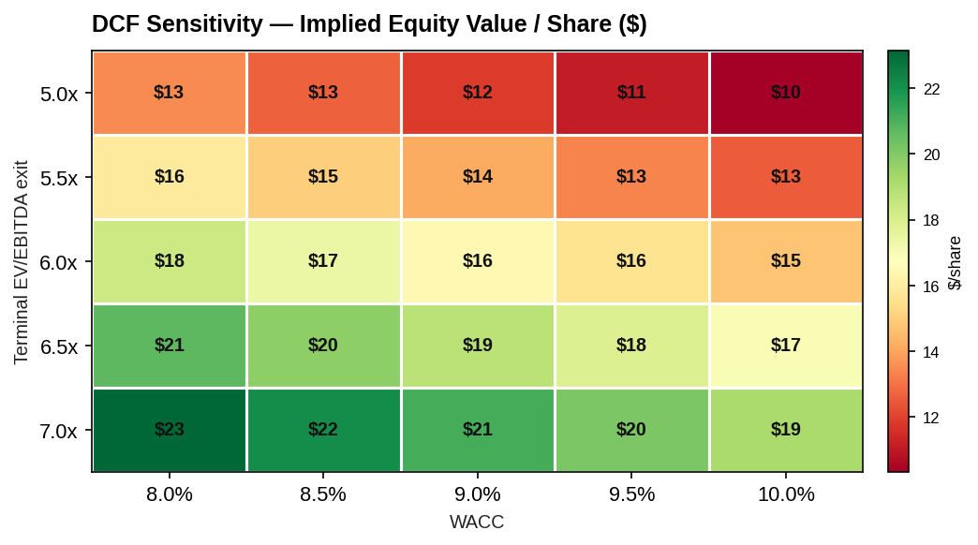
DCF sensitivity — equity value per share
Across WACC 8.0–10.0% and exit 5.0–7.0x, implied equity value spans ~$10–23/share. The $14.00 offer is covered by the lower-left of the grid (higher WACC, lower exit) — the region appropriate for a declining, levered asset.

7.5 Trading comparables
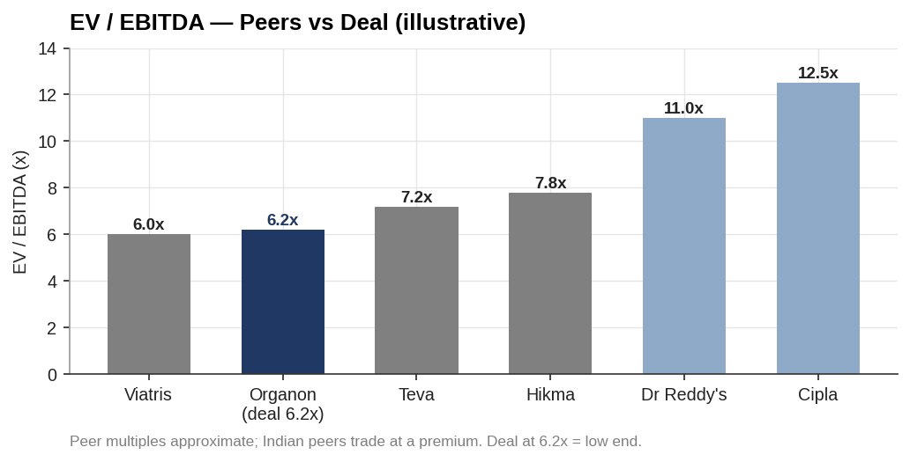
EV/EBITDA — peers vs deal
Peer | EV/EBITDA (approx.) | Profile
Viatris | ~6.0x | Mature generics/brands (closest comp)
Organon (at deal) | 6.2x | This transaction
Teva | ~7.2x | Generics + specialty
Hikma | ~7.8x | Generics/branded
Dr Reddy’s | ~11.0x | Indian generics (premium)
Cipla | ~12.5x | Indian generics (premium)
Relevant range (ex-India) | 6.0–7.5x | Implied EV $11.5–14.3bn
At 6.2x, the deal is at the low end of the relevant (Western generics/mature-brands) range and far below Indian-peer multiples. Implied equity value at 6.0–7.5x: ~$12.9–23.9/share. Peer multiples are approximate and to be tied to each peer’s latest filing.

7.6 Precedent transactions
Precedent | Type | EV/EBITDA (approx.)
Mylan + Upjohn → Viatris (2020) | Mature-brands spin-merge | mid-single digit
STADA (Bain/Cinven, 2017) | Generics LBO | ~high-single digit
Teva / Allergan Generics (2016) | Generics scale (later impaired) | ~low-double digit
Amgen / Horizon (2023) | Growth biopharma (not comparable) | ~20x
Relevant range (mature/generic) |  | 7.0–9.0x
Precedent multiples for control deals in mature pharma cluster ~7–9x, implying EV ~$13.4–17.2bn (~$20–35/share). This overstates Organon’s value — most precedents carried growth or strategic scarcity that Organon lacks — but confirms the offer is undemanding versus history.

7.7 Football field
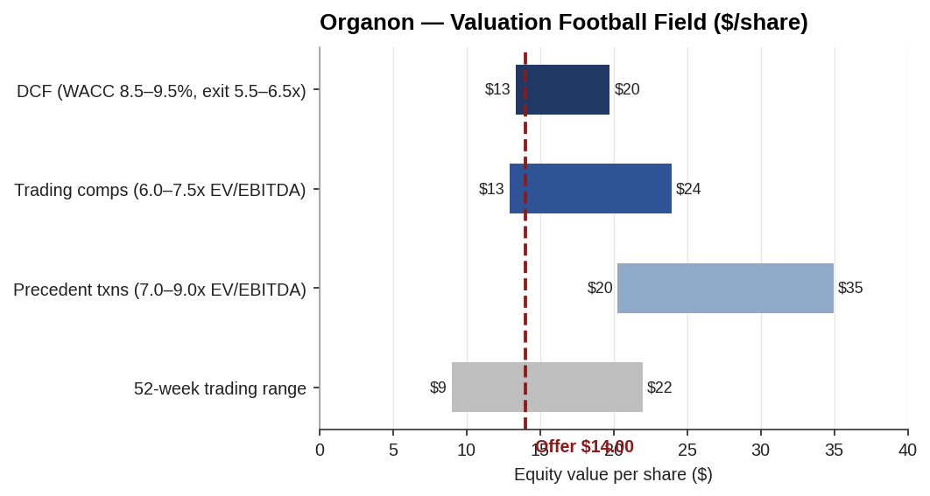
Organon valuation football field
The $14.00 offer sits at the bottom of the DCF and trading-comps ranges, inside the 52-week trading range, and below precedents. No method places fair value below the offer — the transaction is not a premium valuation.

7.8 Scenario analysis
Scenario | Key drivers | EV | Equity/share
Bull | Revenue +1%/yr, margin 31%, exit 6.5x, WACC 8.5% | ~$13.2bn | ~$19.7
Base | Revenue ~flat, margin 30%, exit 6.0x, WACC 9.0% | ~$12.4bn | ~$16.5
Bear | Established-brands decline −4%/yr, margin 28%, exit 5.0x, WACC 10% + Nexplanon impairment | ~$10.0bn | ~$7–9
The bear case — accelerated decline plus a Nexplanon-driven Women’s Health hit — is the only scenario that takes value below the offer. That is precisely the risk Sun underwrites.

7.9 Valuation conclusion
Base-case standalone value: EV ~$12.4bn, equity ~$16.5/share — ~18% above the $14.00 offer. Triangulated across methods, fair value is ~$12–14bn EV / ~$15–18/share. The offer is fair-to-cheap for Sun (a margin of safety of ~15–20% versus base DCF) and defensible for Organon’s board given the standalone leverage, decline and governance overhang that cap the realistic exit. The valuation supports proceeding; the risk is the bear case, quantified next in the merger and risk chapters.

Assumptions & sources
- All DCF inputs (growth, margin, D&A, capex, NWC, tax, WACC, terminal multiple) are analyst assumptions anchored on FY2025 actuals; flagged, not company guidance.
- Shares (~260m) and net debt (~$8.1bn) as prior chapters; confirm from 10-K / proxy.
- Peer and precedent multiples are approximate/illustrative, to be tied to each company’s latest filing and each deal’s disclosure. Indian peers shown for context but excluded from the relevant range (different growth/market).
- Bear-case Nexplanon impairment is a modelled sensitivity, not a quantified disclosure.
- WACC build uses rf 4.5%, ERP 5.5%, beta 1.05, pre-tax Kd 7.0%, 65/35 target structure, +30 bps company-specific premium.
Sources: Organon FY2025 financials (base year); US Treasury / FRED (risk-free); company filings for peer multiples; deal press releases for precedents. Full sourcing in 05_Data/DATA_SOURCES.docx.

